# Supplementary Material—Salish Sea Salmon Qualitative Network Model

Appendix 1. Methods and Data Supporting Figure 1.

Methods

To arrive at population trends, we compiled available adult run sizes for salmon in rivers throughout the Salish Sea. Data were from Pacific Fishery Management Council Stock Assessment and Fishery Evaluation (SAFE) Documents (<http://www.pcouncil.org/salmon/stock-assessment-and-fishery-evaluation-safe-documents/review-of-2015-ocean-salmon-fisheries/>), Pacific Salmon Commission Technical Committee Reports (<http://www.psc.org/publications/technical-reports/technical-committee-reports/chinook/>), Washington Department of Fish and Wildlife, Ogden et al. 2015, and Zimmerman et al. 2015 (Table A1.1). We used the longest time series available (typically from 1970s to >2010) and used the methods of Holmes (2001) to estimate a population trend and confidence interval for each run. If total run size (TRS, a total of catch and escapement or number of spawners) was not available, we used escapement/spawner (E) data.

Table A1.1 Salmon runs used in the calculation of population trends. TRS=Total Run Size, E=Escapement.

|  |  |  |  |  |  |  |  |
| --- | --- | --- | --- | --- | --- | --- | --- |
| Run | Species | Data | Years | Data Source | Subbasin | Population Trend | 95% Confidence Interval |
| Lake Washington | Chinook | TRS | 1975-2014 | PSC Joint Tech. Comm. 2016 | Central Puget Sound | 0.004 | 0.009 |
| Green | Chinook | TRS | 1975-2014 | PSC Joint Tech. Comm. 2016 | Central Puget Sound | -0.027 | 0.006 |
| Snohomish | Chinook | TRS | 1975-2014 | PSC Joint Tech. Comm. 2016 | Whidbey | -0.035 | 0.004 |
| Hood Canal | Chinook | TRS | 1981-2014 | PFMC 2016 | Hood Canal | 0.035 | 0.010 |
| Juan de Fuca | Chinook | TRS | 1981-2014 | PFMC 2016 | Juan de Fuca | -0.006 | 0.006 |
| South Puget Sound | Chinook | TRS | 1981-2014 | PFMC 2016 | South Sound | 0.013 | 0.005 |
| Nooksack | Chinook | TRS | 1981-2014 | PFMC 2016 | San Juan and Gulf Islands | -0.046 | 0.007 |
| Skagit Spring | Chinook | TRS | 1975-2014 | PSC Joint Tech. Comm. 2016 | Whidbey | 0.014 | 0.006 |
| Skagit Summer/fall | Chinook | TRS | 1975-2014 | PSC Joint Tech. Comm. 2016 | Whidbey | -0.026 | 0.005 |
| Stillaguamish | Chinook | TRS | 1975-2014 | PSC Joint Tech. Comm. 2016 | Whidbey | -0.030 | 0.011 |
| Willapa | Chinook | TRS | 1976-2014 | PFMC 2016 | Pacific Coast | 0.021 | 0.007 |
| Grays Harbor Spring/Summer | Chinook | TRS | 1976-2014 | PFMC 2016 | Pacific Coast | 0.018 | 0.005 |
| Grays Harbor Fall | Chinook | TRS | 1975-2014 | PSC Joint Tech. Comm. 2016 | Pacific Coast | 0.013 | 0.005 |
| Queets Spr/Summer | Chinook | TRS | 1976-2015 | PSC Joint Tech. Comm. 2016 | Pacific Coast | -0.025 | 0.007 |
| Queets fall | Chinook | TRS | 1976-2014 | PSC Joint Tech. Comm. 2016 | Pacific Coast | 0.002 | 0.004 |
| Hoh Spring/Summer | Chinook | TRS | 1976-2015 | PSC Joint Tech. Comm. 2016 | Pacific Coast | -0.019 | 0.006 |
| Hoh fall | Chinook | TRS | 1976-2015 | PSC Joint Tech. Comm. 2016 | Pacific Coast | -0.002 | 0.004 |
| Quillayute spring/summer | Chinook | TRS | 1976-2015 | PSC Joint Tech. Comm. 2016 | Pacific Coast | -0.029 | 0.005 |
| Quillayute fall | Chinook | TRS | 1976-2015 | PFMC 2016 | Pacific Coast | -0.005 | 0.005 |
| Hoko fall term | Chinook | TRS | 1986-2015 | PSC Joint Tech. Comm. 2016 | Pacific Coast | 0.021 | 0.009 |
| Fraser Spring/summer | Chinook | TRS | 1975-2015 | PSC Joint Tech. Comm. 2016 | Central Strait of Georgia | 0.017 | 0.002 |
| Harrison | Chinook | TRS | 1984-2015 | PSC Joint Tech. Comm. 2016 | Central Strait of Georgia | 0.050 | 0.004 |
| Lake Shuswap | Chinook | E | 1975-2015 | PSC Joint Tech. Comm. 2016 | Central Strait of Georgia | 0.026 | 0.006 |
| Nanaimo | Chinook | E | 1975-2015 | PSC Joint Tech. Comm. 2016 | South Strait of Georgia, San Juan and Gulf Islands | -0.018 | 0.007 |
| Cowichan | Chinook | E | 1975-2015 | PSC Joint Tech. Comm. 2016 | South Strait of Georgia, San Juan and Gulf Islands | -0.006 | 0.007 |
| Nimpkish | Chinook | E | 1975-2015 | PSC Joint Tech. Comm. 2016 | Johnstone Strait | -0.052 | 0.015 |
| Klinaklini | Chinook | E | 1975-2015 | PSC Joint Tech. Comm. 2016 | Johnstone Strait | 0.030 | 0.009 |
| Kakweiken | Chinook | E | 1975-2015 | PSC Joint Tech. Comm. 2016 | Johnstone Strait | -0.043 | 0.011 |
| Kingcome | Chinook | E | 1975-2015 | PSC Joint Tech. Comm. 2016 | Johnstone Strait | -0.064 | 0.018 |
| Wakeman | Chinook | E | 1975-2015 | PSC Joint Tech. Comm. 2016 | Johnstone Strait | -0.151 | 0.028 |
| Marble | Chinook | E | 1975-2015 | PSC Joint Tech. Comm. 2016 | Pacific Coast | 0.013 | 0.005 |
| Burman | Chinook | E | 1975-2015 | PSC Joint Tech. Comm. 2016 | Pacific Coast | 0.061 | 0.012 |
| Tahsis | Chinook | E | 1975-2015 | PSC Joint Tech. Comm. 2016 | Pacific Coast | 0.024 | 0.014 |
| Artlish | Chinook | E | 1975-2015 | PSC Joint Tech. Comm. 2016 | Pacific Coast | 0.029 | 0.016 |
| Kaouk | Chinook | E | 1975-2015 | PSC Joint Tech. Comm. 2016 | Pacific Coast | 0.041 | 0.026 |
| Tahsish | Chinook | E | 1975-2015 | PSC Joint Tech. Comm. 2016 | Pacific Coast | 0.004 | 0.011 |
| Cedar River Winter | Steelhead | TRS | 1987-2013 | N. Kendall, WDFW pers. comm | Central Puget Sound | -0.220 | 0.023 |
| Green River Winter | Steelhead | TRS | 1978-2013 | N. Kendall, WDFW pers. comm | Central Puget Sound | -0.053 | 0.004 |
| Puyallup/Carbon Winter | Steelhead | TRS | 1983-2013 | N. Kendall, WDFW pers. comm comm | Central Puget Sound | -0.077 | 0.006 |
| White River (Puyallup) Winter | Steelhead | TRS | 1986-2013 | N. Kendall, WDFW pers. comm | Central Puget Sound | -0.042 | 0.008 |
| Englishman River winter | Steelhead | E | 1982-2015 | K. Pellett, pers. comm | Central Strait of Georgia | -0.063 | 0.011 |
| East Hood Canal Winter | Steelhead | TRS | 1989-2013 | N. Kendall, WDFW pers. comm | Hood Canal | 0.088 | 0.016 |
| Skokomish Winter | Steelhead | TRS | 1985-2006 | N. Kendall, WDFW pers. comm | Hood Canal | -0.020 | 0.013 |
| South Hood Canal Winter | Steelhead | TRS | 1988-2013 | N. Kendall, WDFW pers. comm | Hood Canal | -0.004 | 0.009 |
| West Hood Canal Winter | Steelhead | TRS | 2003-2013 | N. Kendall, WDFW pers. comm | Hood Canal | 0.015 | 0.021 |
| Tsitika River summer | Steelhead | E | 1976-2015 | K. Pellett, pers. comm | Johnstone Strait | 0.008 | 0.007 |
| Salmon River winter | Steelhead | TRS | 1981-2015 | N. Kendall, WDFW pers. comm | Johnstone Strait | 0.021 | 0.036 |
| Sequim and Discovery Bays Tributaries Winter | Steelhead | TRS | 1987-2013 | N. Kendall, WDFW pers. comm | Juan de Fuca | -0.101 | 0.100 |
| Strait of Juan de Fuca Independent Tributaries Winter | Steelhead | TRS | 1991-2009 | N. Kendall, WDFW pers. comm | Juan de Fuca | -0.028 | 0.022 |
| Glendale winter | Steelhead | E | 1992-2014 | K. Pellett, pers. comm | Pacific Coast | -0.178 | 0.085 |
| Ahnuhati winter | Steelhead | E | 1992-2014 | K. Pellett, pers. comm | Pacific Coast | -0.186 | 0.065 |
| Kakweiken winter | Steelhead | E | 1992-2014 | K. Pellett, pers. comm | Pacific Coast | -0.206 | 0.063 |
| Atwaykellesse winter | Steelhead | E | 1992-2014 | K. Pellett, pers. comm | Pacific Coast | -0.116 | 0.062 |
| Wahpeeto winter | Steelhead | E | 1992-2014 | K. Pellett, pers. comm | Pacific Coast | -0.201 | 0.066 |
| Heber River summer | Steelhead | E | 1975-2015 | K. Pellett, pers. comm | Pacific Coast | -0.012 | 0.004 |
| Gordon River summer | Steelhead | E | 1998-2015 | K. Pellett, pers. comm | Pacific Coast | 0.030 | 0.042 |
| Nisqually Winter | Steelhead | TRS | 1980-2013 | N. Kendall, WDFW pers. comm | South Sound | -0.107 | 0.016 |
| Samish Winter | Steelhead | TRS | 1979-2013 | N. Kendall, WDFW pers. comm | South Strait of Georgia | 0.039 | 0.011 |
| Pilchuck Winter | Steelhead | E | 1981-2014 | N. Kendall, WDFW pers. comm | Whidbey | -0.020 | 0.009 |
| Skagit River Summer and Winter | Steelhead | TRS | 1978-2013 | N. Kendall, WDFW pers. comm | Whidbey | -0.034 | 0.007 |
| Snohomish System Winter | Steelhead | TRS | 1987-2013 | N. Kendall, WDFW pers. comm | Whidbey | -0.048 | 0.012 |
| Snohomish/Skykomish Winter | Steelhead | TRS | 1987-2013 | N. Kendall, WDFW pers. comm | Whidbey | -0.061 | 0.010 |
| Snoqualmie Winter | Steelhead | TRS | 1987-2013 | N. Kendall, WDFW pers. comm | Whidbey | -0.056 | 0.008 |
| Stillaguamish Winter | Steelhead | TRS | 1987-2013 | N. Kendall, WDFW pers. comm | Whidbey | -0.075 | 0.022 |
| Green | Coho | TRS | 1973-2010 | Zimmerman et al. 2015 | Central Puget Sound | 0.039 | 0.014 |
| Puyallup | Coho | TRS | 1974-2010 | Zimmerman et al. 2015 | Central Puget Sound | -0.038 | 0.008 |
| Big Qualicum | Coho | TRS | 1973-2010 | Zimmerman et al. 2015 | Central Strait of Georgia | -0.143 | 0.011 |
| Inch | Coho | TRS | 1984-2010 | Zimmerman et al. 2015 | Central Strait of Georgia | 0.103 | 0.023 |
| Big Beef Creek | Coho | TRS | 1977-2010 | Zimmerman et al. 2015 | Hood Canal | -0.025 | 0.009 |
| Quilcene | Coho | TRS | 1979-2010 | Zimmerman et al. 2015 | Hood Canal | 0.039 | 0.014 |
| Skokomish | Coho | TRS | 1973-2010 | Zimmerman et al. 2015 | Hood Canal | 0.013 | 0.008 |
| Straits | Coho | TRS | 1985-2010 | Zimmerman et al. 2015 | Juan de Fuca | -0.034 | 0.012 |
| Black | Coho | TRS | 1978-2010 | Zimmerman et al. 2015 | North Strait of Georgia | -0.052 | 0.021 |
| Puntledge | Coho | TRS | 1974-2010 | Zimmerman et al. 2015 | North Strait of Georgia | -0.151 | 0.020 |
| Quinsam | Coho | TRS | 1978-2004 | Zimmerman et al. 2015 | North Strait of Georgia | -0.104 | 0.010 |
| Bingham Creek | Coho | TRS | 1976-2010 | Zimmerman et al. 2015 | Pacific Coast | 0.017 | 0.014 |
| Cowlitz | Coho | TRS | 1982-2010 | Zimmerman et al. 2015 | Pacific Coast | -0.126 | 0.030 |
| Grays | Coho | TRS | 1982-2010 | Zimmerman et al. 2015 | Pacific Coast | -0.036 | 0.009 |
| Quinault | Coho | TRS | 1977-2010 | Zimmerman et al. 2015 | Pacific Coast | 0.079 | 0.015 |
| Robertson | Coho | TRS | 1975-2010 | Zimmerman et al. 2015 | Pacific Coast | -0.014 | 0.013 |
| Satsop | Coho | TRS | 1973-2010 | Zimmerman et al. 2015 | Pacific Coast | 0.036 | 0.010 |
| Washougal | Coho | TRS | 1976-2010 | Zimmerman et al. 2015 | Pacific Coast | -0.102 | 0.023 |
| Deschutes | Coho | TRS | 1977-2008 | Zimmerman et al. 2015 | South Sound | -0.048 | 0.041 |
| Chilliwack | Coho | TRS | 1982-2004 | Zimmerman et al. 2015 | South Strait of Georgia | -0.066 | 0.060 |
| Nooksack | Coho | TRS | 1976-2009 | Zimmerman et al. 2015 | South Strait of Georgia | -0.071 | 0.028 |
| Skagit | Coho | TRS | 1991-2010 | Zimmerman et al. 2015 | Whidbey | -0.049 | 0.014 |
| Stilliguamish | Coho | TRS | 1981-2014 | Zimmerman et al. 2015 | Whidbey | -0.013 | 0.013 |
| Snohomish | Coho | TRS | 1981-2014 | Zimmerman et al. 2015 | Whidbey | -0.026 | 0.010 |
| Baker | Coho | TRS | 1983-2010 | Zimmerman et al. 2015 | Whidbey | -0.048 | 0.018 |
| Skykomish | Coho | TRS | 1978-2010 | Zimmerman et al. 2015 | Whidbey | 0.012 | 0.010 |
| Tulalip Bay | Coho | TRS | 1974-2010 | Zimmerman et al. 2015 | Whidbey | 0.011 | 0.017 |
| Green River (Area 10A) | Pink | TRS | 2001-2013 | A. Dufault, WDFW, pers. comm. | Central Puget Sound | 1.053 | 0.364 |
| Puyallup River (Area 11A) | Pink | TRS | 1959-2013 | A. Dufault, WDFW, pers. comm. | Central Puget Sound | 0.133 | 0.038 |
| Chambers | Pink | TRS | 1959-2013 | A. Dufault, WDFW, pers. comm. | Central Puget Sound | 0.096 | 0.206 |
| Nisqually R. Drainage | Pink | TRS | 1959-2013 | A. Dufault, WDFW, pers. comm. | Central Puget Sound | 0.167 | 0.088 |
| Area 13A streams | Pink | TRS | 1959-2013 | A. Dufault, WDFW, pers. comm. | Central Puget Sound | -0.029 | 0.054 |
| Area 13B streams | Pink | TRS | 1959-2013 | A. Dufault, WDFW, pers. comm. | Central Puget Sound | 0.036 | 0.035 |
| Port Gamble | Pink | TRS | 1959-2013 | A. Dufault, WDFW, pers. comm. | Hood Canal | 0.425 | 0.593 |
| Dosewallips | Pink | TRS | 1959-2013 | A. Dufault, WDFW, pers. comm. | Hood Canal | -0.095 | 0.028 |
| Duckabush | Pink | TRS | 1959-2013 | A. Dufault, WDFW, pers. comm. | Hood Canal | -0.025 | 0.054 |
| Hamma | Pink | TRS | 1959-2013 | A. Dufault, WDFW, pers. comm. | Hood Canal | 0.091 | 0.052 |
| Hoodsport Hatchery | Pink | TRS | 1959-2013 | A. Dufault, WDFW, pers. comm. | Hood Canal | 0.063 | 0.024 |
| Misc 12C | Pink | TRS | 1959-2013 | A. Dufault, WDFW, pers. comm. | Hood Canal | -0.002 | 0.041 |
| Skokomish R. Drainage | Pink | TRS | 1959-2013 | A. Dufault, WDFW, pers. comm. | Hood Canal | 0.093 | 0.055 |
| Dungeness River | Pink | TRS | 1959-2013 | A. Dufault, WDFW, pers. comm. | Juan de Fuca | -0.009 | 0.053 |
| Elwha River | Pink | TRS | 1959-2013 | A. Dufault, WDFW, pers. comm. | Juan de Fuca | -0.182 | 0.093 |
| Nooksack River | Pink | TRS | 1959-2013 | A. Dufault, WDFW, pers. comm. | South Strait of Georgia | -0.012 | 0.035 |
| Samish River | Pink | TRS | 1959-2013 | A. Dufault, WDFW, pers. comm. | South Strait of Georgia | 0.221 | 0.068 |
| Fraser | Pink | TRS | 1959-2011 | Ogden et al. 2015 | South Strait of Georgia | 0.070 | 0.030 |
| Skagit River | Pink | TRS | 1959-2013 | A. Dufault, WDFW, pers. comm. | Whidbey | 0.004 | 0.030 |
| Snohomish River | Pink | TRS | 1959-2013 | A. Dufault, WDFW, pers. comm. | Whidbey | 0.080 | 0.025 |
| Stillaguamish River | Pink | TRS | 1959-2013 | A. Dufault, WDFW, pers. comm. | Whidbey | 0.000 | 0.027 |
| Lake Washington | Sockeye | E | 1972-2015 | A. Dufault, WDFW, pers. comm. | Central Puget Sound | -0.005 | 0.006 |
| Fraser | Sockeye | TRS | 1960-2012 | Ogden et al. 2015 | South Strait of Georgia | 0.003 | 0.004 |
| Baker Lake | Sockeye | E | 1970-2015 | A. Dufault, WDFW, pers. comm | Whidbey | 0.044 | 0.012 |
| Misc 10 -Seattle | Chum | TRS | 1968-2009 | A. Dufault, WDFW, pers. comm | Central Puget Sound | 0.084 | 0.009 |
| Green-Duwamish River | Chum | TRS | 1968-2009 | A. Dufault, WDFW, pers. comm | Central Puget Sound | 0.135 | 0.014 |
| Misc 10e -Port Orchard | Chum | TRS | 1968-2009 | A. Dufault, WDFW, pers. comm | Central Puget Sound | 0.022 | 0.007 |
| Misc 11 -Tacoma | Chum | TRS | 1968-2009 | A. Dufault, WDFW, pers. comm | Central Puget Sound | 0.020 | 0.006 |
| Puyallup River | Chum | TRS | 1968-2009 | A. Dufault, WDFW, pers. comm | Central Puget Sound | 0.062 | 0.012 |
| Port Gamble Pens (9a) | Chum | TRS | 1968-2009 | A. Dufault, WDFW, pers. comm | Hood Canal | -0.016 | 0.009 |
| N. Hood Canal (12) | Chum | TRS | 1968-2009 | A. Dufault, WDFW, pers. comm | Hood Canal | -0.015 | 0.008 |
| Misc 12b -Hood Canal | Chum | TRS | 1968-2009 | A. Dufault, WDFW, pers. comm | Hood Canal | 0.013 | 0.007 |
| Quilcene River (12a) | Chum | TRS | 1968-2009 | A. Dufault, WDFW, pers. comm | Hood Canal | 0.034 | 0.011 |
| Misc 12c -Hood Canal | Chum | TRS | 1968-2009 | A. Dufault, WDFW, pers. comm | Hood Canal | 0.063 | 0.006 |
| Hoodsport Hatchery | Chum | TRS | 1968-2009 | A. Dufault, WDFW, pers. comm | Hood Canal | 0.049 | 0.010 |
| Skokomish River | Chum | TRS | 1968-2009 | A. Dufault, WDFW, pers. comm | Hood Canal | 0.073 | 0.007 |
| Misc 12d -Hood Canal | Chum | TRS | 1968-2009 | A. Dufault, WDFW, pers. comm | Hood Canal | 0.025 | 0.007 |
| Dungeness River | Chum | TRS | 1968-2009 | A. Dufault, WDFW, pers. comm | Juan de Fuca | 0.052 | 0.012 |
| Elwha River | Chum | TRS | 1968-2009 | A. Dufault, WDFW, pers. comm | Juan de Fuca | -0.061 | 0.014 |
| Misc Strait Streams | Chum | TRS | 1968-2009 | A. Dufault, WDFW, pers. comm | Juan de Fuca | 0.023 | 0.009 |
| Grays Harbor Wild Runsize | Chum | TRS | 1968-2009 | A. Dufault, WDFW, pers. comm | Pacific Coast | -0.006 | 0.006 |
| Willapa Bay Wild And Hatchery Escapement And Total Runsize | Chum | TRS | 1980-1999 | A. Dufault, WDFW, pers. comm | Pacific Coast | -0.010 | 0.006 |
| Inside South Coast (Non-Fraser) | Chum | TRS | 1953-2012 | Ogden et al. 2015 | Pacific Coast | 0.000 | 0.005 |
| Hecate Lowlands | Chum | E | 1954-2012 | Ogden et al. 2015 | Pacific Coast | -0.014 | 0.004 |
| North Haida Gwaii | Chum | E | 1954-2012 | Ogden et al. 2015 | Pacific Coast | -0.028 | 0.009 |
| Portland Inlet | Chum | E | 1954-2012 | Ogden et al. 2015 | Pacific Coast | -0.006 | 0.005 |
| Rivers Inlet | Chum | E | 1954-2012 | Ogden et al. 2015 | Pacific Coast | -0.009 | 0.014 |
| Skidegate | Chum | E | 1954-2012 | Ogden et al. 2015 | Pacific Coast | -0.013 | 0.006 |
| Misc 13 -South Puget Sound | Chum | TRS | 1968-2009 | A. Dufault, WDFW, pers. comm | South Sound | -0.018 | 0.050 |
| Chambers Creek | Chum | TRS | 1968-2009 | A. Dufault, WDFW, pers. comm | South Sound | 0.004 | 0.032 |
| Nisqually River | Chum | TRS | 1968-2009 | A. Dufault, WDFW, pers. comm | South Sound | 0.026 | 0.054 |
| Misc 13a -Minter Creek | Chum | TRS | 1968-2009 | A. Dufault, WDFW, pers. comm | South Sound | 0.062 | 0.008 |
| Misc 13b -Olympia | Chum | TRS | 1968-2009 | A. Dufault, WDFW, pers. comm | South Sound | 0.029 | 0.003 |
| Nooksack River | Chum | TRS | 1968-2009 | A. Dufault, WDFW, pers. comm | South Strait of Georgia | 0.019 | 0.005 |
| Samish River | Chum | TRS | 1968-2009 | A. Dufault, WDFW, pers. comm | South Strait of Georgia | 0.007 | 0.010 |
| Misc 7b Streams | Chum | TRS | 1968-2009 | A. Dufault, WDFW, pers. comm | South Strait of Georgia | 0.082 | 0.011 |
| Skagit River | Chum | TRS | 1968-2009 | A. Dufault, WDFW, pers. comm | Whidbey | -0.026 | 0.006 |
| Tulalip Tribe | Chum | TRS | 1968-2009 | A. Dufault, WDFW, pers. comm | Whidbey | 0.063 | 0.013 |
| Snohomish River | Chum | TRS | 1968-2009 | A. Dufault, WDFW, pers. comm | Whidbey | -0.001 | 0.011 |
| Stillaguamish River | Chum | TRS | 1968-2009 | A. Dufault, WDFW, pers. comm | Whidbey | -0.011 | 0.008 |

Appendix 2. Model Sensitivity Analysis

Methods

To assess the sensitivity of the model linkages in the simulations, we calculated means and standard deviations of the weights for all linkages from the pool of accepted models. Our hypothesis was that some linkages would be more influential in model stability and that those with mean weights different than the expected mean (*µ*=0.5, given assignments that were random (*U(0,1)*)) would provide some indication of linkage sensitivity.

Results

Our sensitivity analysis showed that most model edges (linkages between groups) were stable with regard to the weights applied in the simulation routine, with means from the pool of balanced models very close to the expected mean of 0.5 (>75% of 148 edges). However, some model linkages in the pool of accepted models had mean weights above or below the expected mean and we considered these model groups more sensitive (Fig. A2.1). Linkages among salmon traits were most sensitive, with means in the balanced models considerably higher or lower than the expected mean (e.g., Fitness to Size and Survival to Abundance, self-limiting loops on salmon traits). However, some food web components such as Ichthyoplankton and Forage Fish were also in the group of lower-than-expected model means, suggesting that certain food web pathway weights were sensitive in the model simulations. The links with bidirectional connectivity (positive feedbacks, e.g. Fitness to Size, arrows shown in royal blue in Fig. 2) tended to be the most sensitive to the weighting scheme, with lower-than-average weights resulting in balanced models. Model linkages with mean weights above the expected mean included many high trophic level linkages (e.g., Piscivorous Fish to Marine Mammals), as well as self-limiting loops (salmon traits especially), highly connected nodes (e.g. Zooplankton), and top-level predators (Marine Mammals and Piscivorous Birds). The linkages with both higher- and lower-than-expected means (that were not self-limiting loops) tended be highly connected food web components rather than anthropogenic impacts or physical drivers.

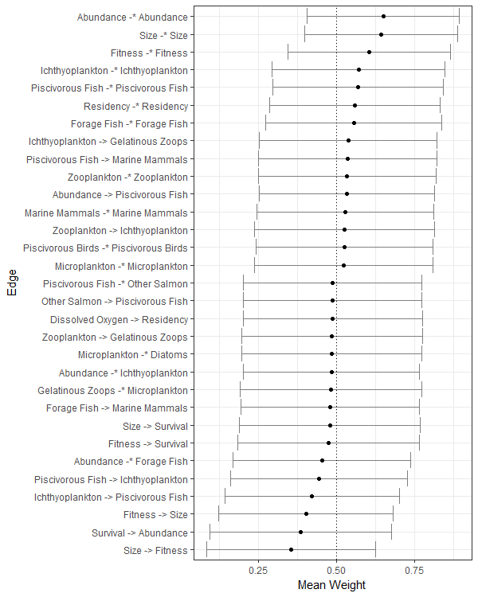

Figure A2.1. Calculated means and standard deviations from all model runs for edges (model linkages) with mean values different from the expected mean (0.5). The expected mean is denoted by the black dashed line. Positive linkages are indicated by an arrow and negative linkages are indicated by a dash and asterisk.

Appendix 3. Model Perturbations and References

|  |  |  |  |
| --- | --- | --- | --- |
| **Drivers** | **Variables** | **Reference** | **Invoked Perturbation** |
| *Environmental* | Sunlight | Littell et al. 2009 | ↑ |
|  | Winter Storms | Littell et al. 2009 | ↑ |
|  | Precipitation | Mauger et al. 2015, Littell et al. 2009 | ↑ |
|  | Upwelling[1] | Mauger et al. 2015 | ↓ |
|  | Stratification[2] | Mauger et al. 2015 | ↑ |
|  | Temperature | Littell et al. 2009, Field et al. 2006, Hollowed et al. 2001 | ↑ |
|  | River Flow | Littell et al. 2009[3] | ↑ |
|  | Turbidity | PSEMP 2016, WADOE 2017 | ↓ |
|  | Dissolved Oxygen | Roberts et al. 2014 | ↓ |
| *Production* | Nutrients | Roberts et al. 2014 | ↑ |
|  | Microplankton | Moore et al. 2015 | ↑ |
|  | Microbial Detritivores | PSEMP 2016 | ↑ |
|  | Diatoms | Brandenberger 2008, WADOE 2017 | ↓ |
| *Food web* | Zooplankton[4] | Li et al. 2013 | ↓ |
|  | Gelatinous Zooplankton | Greene et al. 2015 | ↑ |
|  | Forage Fish | Greene et al. 2015 | ↓ |
|  | Ichthyoplankton | Palsson et al. 1998 | ↓ |
|  | Other Salmon | PFMC 2016, Figure 1 | ↑ |
|  | Piscivorous Fish | Palsson et al. 1998 | ↓ |
|  | Piscivorous Birds | Gaydos and Pearson 2011, Anderson et al. 2009 | ↓ |
|  | Marine Mammals | Chasco et al. 2017 | ↑ |
| *Anthropogenic* | Hatcheries | Christie et al. 2012, Waples 1999 | ↑ |
|  | Harvest[5] |  | ↑ |
|  | Habitat Loss | Puget Sound Water Quality Action Team 2002 | ↑ |
|  | CO2 | Feely et al. 2010 | ↑ |
|  | Global Warming | IPCC 2014 | ↑ |
|  | Contaminants | O’Neill et al. 2009, Meador et al. 2006, Crecelius et al. 1995 | ↑ |
|  | Disease | SSMSP Hypotheses | ↑ |

Literature Cited

Anderson, E.M., Bower, J.L., Nysewander, D.R., Evenson, J.R. and Lovvorn, J.R.  2009.  Changes in avifaunal abundance in a heavily-used wintering and migration site in Puget Sound, Washington during 1966–2007. *Marine Ornithology* 37: 19-27.

Burke, B. J., B. R. Beckman, W. T. Peterson, C. Morgan, E. A. Daly, M. Litz. 2013. Multivariate methods to forecast Pacific salmon returns. *PLoS ONE* 8(1): e54134.

Chasco, B. I. Kaplan, A. Thomas, A. Alejandro-Gutiérrez, D.P. Noren, M.J. Ford, M.B. Hanson, J. Scordino, S.J. Jeffries, S.F. Pearson, K. Marshall, E.J. Ward. 2017. Estimates of Chinook salmon consumption in Washington State inland water by four marine mammal predators from 1970-2015. *Can. J. of Fish. and Aqua. Sci. 10.1139/cjfas-2016-0203*

Christie, M.R., M.L. Marine, R.A. French, R.S. Waples and M.S. Blouin. 2012. Effective size of a wild salmonid population is greatly reduced by hatchery supplementation. *Heredity* 109: 254-260.

Crecilius, E.A., V.I. Cullinan, L.F. Lefkovitz and C. Peden. 1995. Historical trends in the accumulation of chemicals in Puget Sound. 825-831, in Volume 2, Puget Sound Research '95 Proceedings, Puget Sound Water Quality Authority, Olympia.

Feely, R. A., S. R. Alin, J. Newton, C. L. Sabine, M. Warner, A. Devol, C. Krembs, and C. Maloy. 2010. The combined effects of ocean acidification, mixing, and respiration on pH and carbonate saturation in an urbanized estuary. *Estuarine, Coastal and Shelf Science*, 88, 442-449, doi:10.1016/j.ecss.2010.05.004

Field, D., D. Cayan, and F. Chavez. 2006. Secular warming in the California current and North Pacific. *California Cooperative Oceanic Fisheries Investigations Reports*, 47, 92-108.

Hoekstra, J. M., K.K. Bartz, M.H. Ruckelshaus, J.M. Moslemi, and T.K. Harms. 2007. Quantitative threat analysis for management of an imperiled species: Chinook salmon (*Oncorhynchus tshawytscha*). *Ecological Applications*, 17: 2061-2073.

Hollowed, A. B., S. R. Hare, and W. S. Wooster. 2001. Pacific Basin climate variability and patterns of Northeast Pacific marine fish production. *Progress in Oceanography*, 49, 257-282, doi:10.1016/S0079-6611(01)00026-X.

Gaydos, J.K. and S.F. Pearson. 2011. Birds and mammals that depend on the Salish Sea: A compilation. *Northwest Naturalist*: 92:79–94.

Intergovernmental Panel on Climate Change. 2014. Climate Change 2014: Synthesis Report. Contribution of Working Groups I, II and III to the Fifth Assessment Report of the Intergovernmental Panel on Climate Change [Core Writing Team, R.K. Pachauri and L.A. Meyer (eds.)]. IPCC, Geneva, Switzerland, 151 pp.

Li, L., D. Mackas, B. Hunt, J. Schweigert, E. Pakhomov, I. Perry, M. Galbraith, T.J. Pitcher. 2013. Zooplankton communities in the Strait of Georgia, British Columbia, track large-scale climate forcing over the Pacific Ocean. *Progress in Oceanography*. doi:http://dx.doi.org/10.1016/j.pocean.2013.05.025

Littell, J.S., M. McGuire Elsner, L.C. Whitely Binder, and A.K. Snover (eds). 2009. *The Washington Climate Change Impacts Assessment: Evaluating Washington's Future in a Changing Climate.* Climate Impacts Group, University of Washington, Seattle, Washington. Available at: [www.cses.washington.edu/db/pdf/wacciaexecsummary638.pdf](http://www.cses.washington.edu/db/pdf/wacciaexecsummary638.pdf)

Mauger, G.S., J.H. Casola, H.A. Morgan, R.L. Strauch, B. Jones, B. Curry, T.M. Busch Isaksen, L. Whitely Binder, M.B. Krosby, and A.K. Snover. 2015. State of Knowledge: Climate Change in Puget Sound. Report prepared for the Puget Sound Partnership and the National Oceanic and Atmospheric Administration. Climate Impacts Group, University of Washington, Seattle. doi:10.7915/CIG93777D

Meador, J.P., F.C. Sommers, G.M. Ylitalo, C.A. Sloan. 2006. Altered growth and related physiological response in juvenile Chinook salmon (*Oncorhynchus tshawytscha*) from dietary exposure to polycyclic aromatic hydrocarbons (PAHs). *Can. J. of Fish. and Aqua. Sci.* 63: 2364-2376.

Moore, S.K. et al., 2011. Past trends and future scenarios for environmental conditions favoring the accumulation of paralytic shellfish toxins in Puget Sound shellfish. *Harmful Algae*, 10, 521-529.

Moore, S.K. et al., 2015. Present-day and future climate pathways affecting the harmful algal blooms species *Alexandrium catenella* in Puget Sound, WA, USA. *Harmful Algae*, 48, 1-11. 25

O'Neill, S.M., and West, J.E. 2009. Marine Distribution, Life History Traits, and the Accumulation of Polychlorinated Biphenyls in Chinook Salmon from Puget Sound, Washington*. Transactions of the American Fisheries Society* 138(3): 616-632.

Pacific Fishery Management Council. 2016. Review of 2015 Ocean Salmon Fisheries: Stock Assessment and Fishery Evaluation Document for the Pacific Coast Salmon Fishery Management Plan. Pacific Fishery Management Council, Portland, Oregon. http://www.pcouncil.org/wp-content/uploads/2016/02/Review_of_2015_Salmon_Fisheries_FullDocument.pdf

Palsson, W.A., T.J. Northrup, and M.W. Baker. 1998. Puget Sound Groundfish Management Plan. Washington Department of Fish and Wildlife. Olympia, WA.

PSEMP Marine Waters Workgroup. 2016. Puget Sound marine waters: 2015 overview. S. K. Moore, R. Wold, K. Stark, J. Bos, P. Williams, K. Dzinbal, C. Krembs and J. Newton (Eds). URL: www.psp.wa.gov/PSEMP/PSmarinewatersoverview.php.

Puget Sound Water Quality Action Team. 2002. *2002 Puget Sound Update: Eighth Annual Report of the Puget Sound Ambient Monitoring Program*. Puget Sound Water Quality Action Team. Olympia, Washington.

Roberts, M., T. Mohamedali, B. Sackmann, T. Khangaonkar, W. Long. 2014. Puget Sound and the Straits Dissolved Oxygen Assessment Impacts of Current and Future Human Nitrogen Sources and Climate Change through 2070. Washington State Department of Ecology, Publication No. 14-03-007. Olympia, WA.

Waples, R.S. 1999. Dispelling some myths about hatcheries. *Fisheries* 24: 12–21.

WADOE. 2017. Marine Waters Program, Washington Department of Ecology. http://www.ecy.wa.gov/programs/eap/mar_wat/

Appendix 4. Model Output for Individual Perturbations

Model output showing 6 model nodes of interest: Salmon Survival, Salmon Abundance, Salmon Size, Residency, Fitness and Other Salmon. Other Salmon refers to the populations (chum, pink, and sockeye) which have not seen a noticeable decline in survival in recent decades. In each plot box, the model node that was perturbed is shown in the title, with the direction of the press (Increase or Decrease) shown below. The bar graphs indicate the proportion of model simulations with negative (red bars) and positive (blue bars) outcomes for that model node, given the invoked press perturbation. Where the bars are dark gray, there was no impact to those nodes.

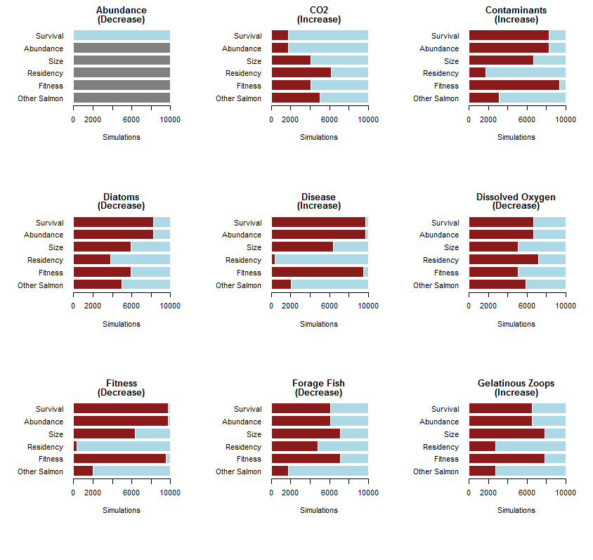

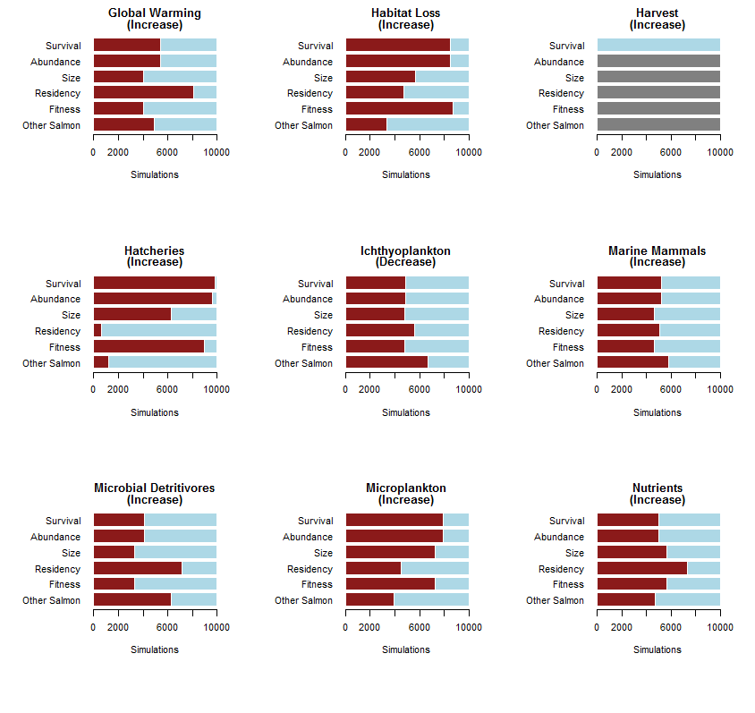

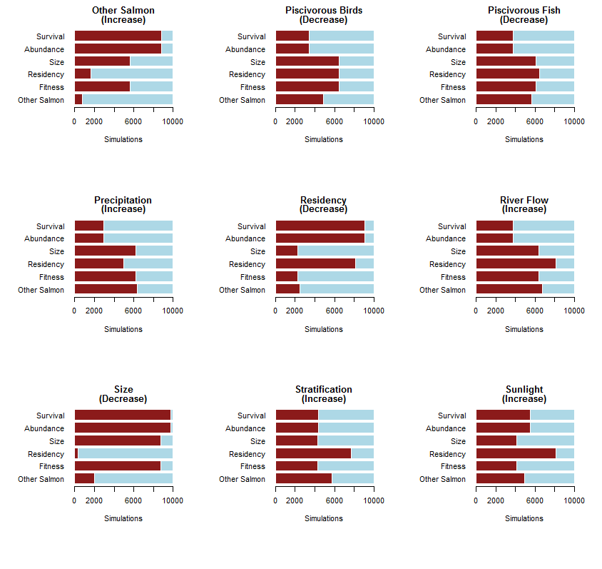

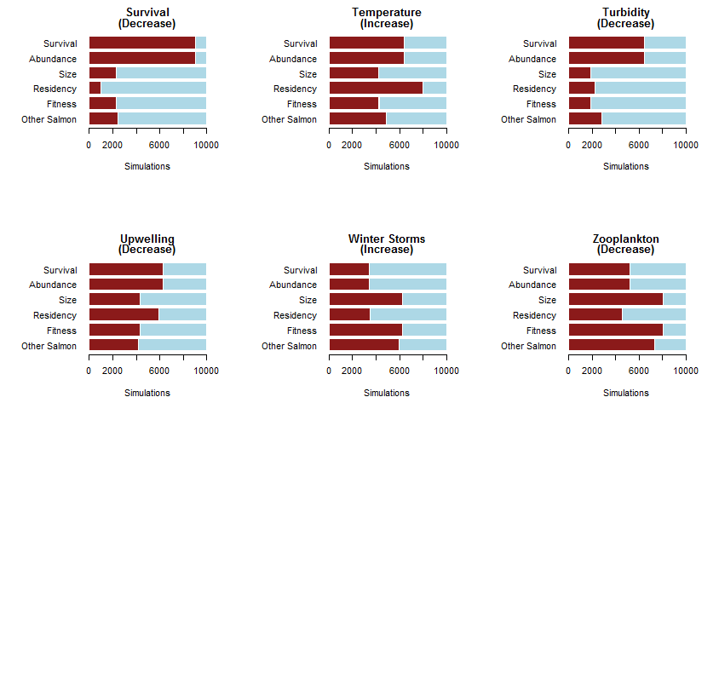

1. While impacts to upwelling are unknown, we invoked a decrease in upwelling because it would reduce the delivery of nutrients to Puget Sound and potentially disrupt primary production.
2. Decreased mixing as a result of changes in freshwater flow could lead to increased stratification; while the exact response is unknown (see Mauger et al. 2015), we have invoked an increase in stratification because decreased mixing would likely lead to declines in primary productivity.
3. River flow is projected to be higher during the winter/spring period of salmon outmigration, but lower in the summers due to decreased precipitation and higher temps. during this season (Littell et al. 2009).
4. While it is unknown if total abundance of zooplankton has decreased, there is some indication that the community has shifted. We invoked a decrease in zooplankton to reflect this shift.
5. Harvest has decreased over the time period we used to frame this analysis; however, we were interested in the impacts of increased harvest on salmon survival so invoked an increase in harvest as the perturbation